  - Non-Intrusive Techniques for Occupancy Sensing with Office AHU Long-term Data
Reproduced paper of "Non-Intrusive Techniques for Establishing Occupancy Related Energy Savings in Commercial Buildings [1]"
Linzhang Wu
Electrical and Computer Engineering Department
Rutgers University Piscataway NJ
lw568@scarletmail.rutgers.edu
Khandaker Hossain
Electrical and Computer Engineering Department
Rutgers University Piscataway NJ
kmh312@scarletmail.rutgers.edu

ABSTRACT
Room occupancy prediction is necessary for building management systems to control building parameters such as power consumption, monitor and adjust heating, ventilation and air conditioning fans. Methods such as using cameras to collect live footage prove to be the most reliable. The live footage can be processed to count how many persons occupy a given room. Unfortunately, this is an intrusive way to user privacy and would not be accepted by many households. Non-intrusive mechanisms, on the other hand, have had limitations. Their binary state cannot account for the real number of people present in a room. Leveraging machine learning makes it possible to predict the room occupancy from a non-intrusive array of sensor data.
Using the internet of things network, various sensor nodes measuring the temperature, humidity, light, carbon (IV) oxide, and passive infrared sensor data can be collected and transmitted to a central processing unit. With huge amounts of data collected, a machine learning algorithm can be used to learn the information from the data and be used for future training purposes. This paper looks at the application of machine learning on a set of internet of things data to create a model for classifying future data collected from the field in a non-intrusive mechanism

The HVAC systems traditionally run on a static schedule that does not adapt to the occupancy state, causing significant energy waste in conditioning or partially occupied zones. Room occupancy prediction is necessary for building management systems to control building parameters such as power consumption, monitor and adjust heating, ventilation and air conditioning fans. The original paper investigated the non-intrusive techniques to obtain a rough occupancy state from coarse-grained measurements of sensors that are commonly available through the building management system without additional sensor installed. As undergraduate student majoring in electrical and computer engineering, it is a valuable opportunity learn and explore machine learning techniques by reproducing a professional research paper. In this paper, we will mimic the approaches and objectives in the original paper to indicate human occupancy pattern and generate zone-customized schedule.

KEYWORDS
Non-intrusive Sensing; HVAC Optimization; Occupancy Monitoring; Zone-customized Schedules;
1. INTRODUCTION
Buildings are the single largest energy consuming sector in the United States. Buildings constitute around 40% of total energy and 70% of the overall electricity usage in the United States. Commercial buildings could save up to $60 billion if investments in energy efficiency were ramped up by just 1-4%, according to a study by the American Council for an Energy Efficient Economy (ACEEE). Office buildings in the U.S. use an average of 17.3 kilowatt-hours (kWh) of electricity and 31.8 cubic feet of natural gas per square foot (ft2) annually. (Data is calculated using a 2003 U.S. Energy Information Administration survey of commercial buildings.). Before machine learning was ever applied to facilities management, the HVAC, heating and cooling systems etc. operated in a way that didn't take human presence into account, which would inevitably lead to energy being wasted. Applying schedules that take the variable occupancy pattern within a building into consider can potentially
Predicting room occupancy is one of the many applications of machine learning which can solve the problem of intrusive methods such as using live cameras. Instead of living footage, individual parameters associated with room occupancy can be determined using machine learning and at given set-points, the average number of persons in a room, for instance, can be identified with high accuracy. Modern construction projects include a coordinated layer of systems that monitor and control critical parameters of a construction. Such systems range from lighting automation, distribution, and control, power consumption monitoring and control, heating ventilation and air conditioning systems and other specific parameter measurements such as temperature control depending on the preferences. This information runs through a communication channel from the sensor nodes to a central building management system (BMS) using a variety of communication protocols (Abade et. al). With advancements in internet connectivity and communication technologies, wireless networks and fiber optics have become increasingly useful in these sectors.
The use of the internet of things in building management systems allows the managers to collect data on numerous building parameters and record the data on cloud servers from different locations with ease. Data from many individual buildings can thus be successfully collected and recorded. The larger the quantity of data collected the more suitable it is for analysis and inference using various scientific methods such as machine learning, the use of neural networks in deep learning as well as basic statistical analysis (Abade et. al). Advanced algorithms can be applied to the data to yield the desired results. This paper demonstrates a machine learning approach in which data collected over the internet of things is used to predict room occupancy. Various data sets collected over a period are provided and used to model a learning machine that will then be used on real-time data fed on it. The data set comes from several sensors that collect non-intrusive information such as carbon (IV) oxide concentrations, humidity, and passive infrared sensor information among others from the internet of things network (Abade et. al). The focus of this paper is on the machine learning model and the outputs it’s able to generate.
2. RELATED WORKS
Multiple research efforts have been conducted with the intent of contributing advancements into HVAC (Heating, Ventilation and Air Conditioning) optimization. As the field of machine learning has advanced, it has been implemented in simplifying facilities management operations, particularly occupancy detection. These studies have helped building managers operate HVAC, air conditioning and WIFI functions as well as energy efficiency.
The advent of various interesting wireless technologies such as LoRa (Long range) wide area network technologies and Sigfox which are low power communication technologies over long distances provides room for interesting applications in the internet of things (IoT) projects (Abade et. al). Data can be exchanged seamlessly without huge power consumption over very long distances. This has contributed immensely to the proliferation of the internet of things startups all around the world. The introduction of these technologies filled the gap where other existing technologies such as Wi-Fi were greatly limited and could not be implemented to cover longer distances without extra costs on power consumption. The Internet of things has made it possible to standardize the results of algorithms applied to different data sources. Initially, it was quite difficult to approve data collected from an individual building due to the isolated nature of the training data used for an algorithm. This had profound limitations on the applications of machine learning in IoT projects. Collecting large data over the internet of things networks is crucial to improving the accuracy and response of training machine learning algorithms.
One most basic level of occupancy inference is to detect occupancy that determines whether a predefined space is occupied or not. Thousands of sensors embody buildings which help by providing real-time data and assisting in promoting predictive maintenance that reduces repairs and breakdowns. The Office building focused had sensor types typically includes 5 types of measurements: CO2 concentration, room air humidity, room temperature, luminosity, and PIR motion sensor data. These sensor types incorporate intrusive techniques. Irvan Arief-Ang (et. al) present a semi supervised domain adaptation method for carbon dioxide - Human Occupancy Counter Plus Plus a robust way to estimate the number of people within in one room by using data from a carbon dioxide sensor [2]. M.S.Zuraimi[3] (et. al) apply SVM and ANN models utilizing CO2 combination and statistical models in large volume space to predict occupancy count.
The original paper utilized non-intrusive techniques whereas our approach requires us to use intrusive techniques since that’s what our data set is based upon. Methods such as using cameras to collect live footage prove to be the most reliable. The live footage can be processed to count how many persons occupy a given room. Unfortunately, this is an intrusive way to user privacy and would not be accepted by many households. Non-intrusive mechanisms, on the other hand, have had limitations. Their binary state cannot account for the real number of people present in a room. Leveraging machine learning makes it possible to predict the room occupancy from a non-intrusive array of sensor data. Guopeng Liu, PhD, PE Michael R. Brambley, PhD (et. al) evaluate occupancy data of each room, each zone and the whole building are collected and transferred to the building automation system (BAS) in real time using a wireless sensor network.[4]
Ardakanian and Bhattacharya have hypothesized that utilizing scalable time series analysis techniques that operates on a custom per zone schedule combined with a rough estimate of occupancy obtained from occupancy indicative sensors can lead to the conservation of more energy. The research team’s methodology geared towards solving this problem consisted of establishing a testbed of 3 campus buildings, empirical mode distribution was then used to decompose signals obtained from sensors. The graphs that showcases the inefficiency of HVAC systems are graphs a & b depicted in figure 7. The graphs that showcased the results of their labor can be found in graphs a - f in figure 8. The research team did succeed in creating higher energy savings whilst reducing violation through the application of non-intrusive techniques.
3. BACKGROUD AND FEASIBILITY
Modern houses and commercial buildings consume a lot of power to keep various parameters of the building under acceptable and comfortable standards for human occupancy. Sensor nodes positioned in various locations of the entire building collect data on temperature, pressure, light, occupancy, atmospheric gas concentration ratios among many others to ensure set-points are acceptable. This data makes it possible to provide services such as security to the room occupants. Heating, ventilation and air condition as well as light automation to ensure ambient light always. Optimizing these parameters usually requires knowledge of the individuals occupying a given room at a given time. Some applications use passive infrared mechanisms to determine occupancy. Others use live footage which is subjected to complex algorithms for processing the data. While live footage is an accurate mechanism, its intrusive nature makes it a candidate for violation of privacy rights. On the other hand, a single passive infrared data cannot predict the number of people in one instance as it only informs the system on whether a room is vacant or not. Knowing the number of room occupants provides information that can be used to limit the power consumption of the HVAC systems, provide customized light automation and even room temperature control. Further applications can be used to provide information to the building management systems on the number of services or workers that would match the demand of services by those occupying a room.

The paper we propose to reproduce is investigated and evaluated the techniques to develop customized per-zone schedules that incorporate a rough human occupancy estimation using scalable time series from coarse-grained measurements of occupancy indicative sensors available through the Building Management System (BMS). All commercial buildings are essentially equipped with one or more Air Handling Units (AHUs) in such HVAC system under BMS. Figure 1 is extracted from the original paper’s presentation to illustrate the HVAC system and give an overview of BMS and its air handling units that used to predict occupancy. 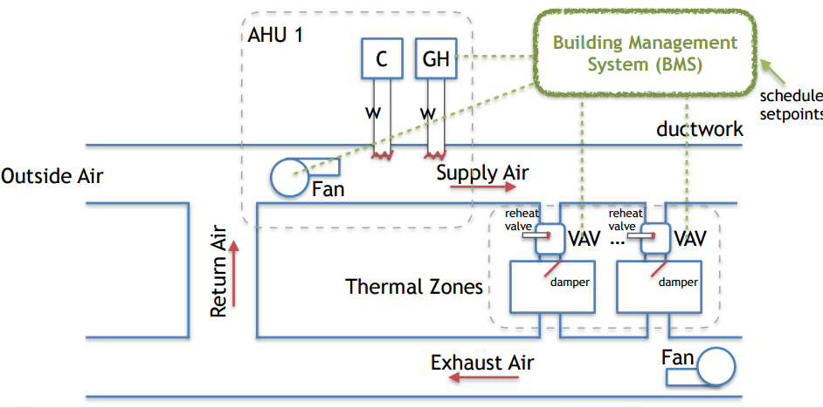
Figure 1. Commercial Building’s HVAC system

Occupancy have impacts on VAV control: a human entry raises the amount of heat load in the thermal zone due to heat dissipated from body and heat generated by appliances usage. The VAV control reacts to such heat change to maintain the operating point by reheating or allow more air flow to cool down. It can be archived by adjusting the reheat valve and damper position. Such responses provide sufficient information to indicate the occupancy state. In the original paper, they refer this sensor (reheat valve or damper position sensor) as occupancy indicative sensor and its reading constitute the occupancy indicative signal. In our paper, we follow the same principle and approaches for obtaining the raw data. In particular, the reheat valve closes to a certain extend according to the room being occupied and opens when it returns to empty again. Note that the conduction heat transfer and solar radiation have effects on this system action.

4. METHODOLOGY
The main objective of this report is to predict room occupancy using non-intrusive method. Figure 2 is an overview of our specific objectives.

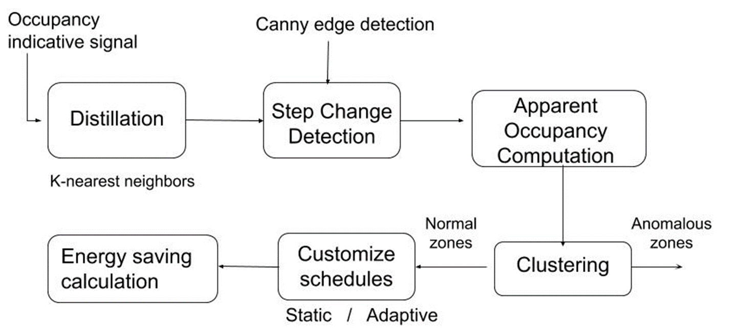
Figure 2. System framework overview

- Utilize the power of machine learning to model the prediction algorithm
- Predict room occupancy based on data obtained from an internet of things array of sensor nodes.
- Demonstrate the working algorithm in python for room occupancy prediction.

In this section we will follow the routines and algorithms in the original paper to process the data and generate models.

*Before we changed from an intrusive data set into a non-intrusive dataset, this is the procedure we followed as first time machine learning professionals,

First Attempt Procedure

The data set obtained from machine learning contained information on four variable parameters. Four parameters were measured using sensors on internet of things network and stored as comma-separated values in excel format. The data obtained included a specific sensor id that was labeled based on their location in the network configuration for individual room occupancy. The parameters in the data included passive infrared sensor data, temperature data, lighting data, CO2 data and humidity data (Hong et. al). Each data point had a specific sensor id for each point at which the data was measured. Using python pandas, the data was imported from the comma-separated value files and sorted into pandas data frame based on the sensor id.
In order to begin programming the data set, the various libraries were first imported into Jupyter notebooks as the programming interface. These libraries included numpy for scientific data processing, pandas used for handling data variables, matplotlib used for plotting graphics including scatter plots and line graphs. The data was then combined into a single CSV file from all the sensor data such that each sensor node Id and its attribute data points for each of the measured element was recorded against each sensor id. The data was then read from the CSV data files into panda’s data frame and converged into one single panda's data frame. However, due to memory errors on combined each of the single files, one folder was used as a sample to demonstrate the model as working. For a full analysis, a larger memory computing environment would be needed to solve the large data problem. Additionally, another process involving a step by step incremental training method would have to be followed to successfully use the data for training and prediction when the memory resources of the computing device are limited. Each of the CSV files was then merged into one panda's data frame for ease of manipulation. From the code ten of the combined data samples are printed to show the nature of the data as depicted in figure 1 below. The data shows the sensor id for each sensor node classified by location, then the elements measured by the sensor node. In this case temperature, CO₂, humidity, light and passive infrared data for one sensor node id.
The data frame was then classified as labels and features so as to split it into testing and training data. The PIR sensor information was used as the label for occupancy whereas temperature, humidity, light and CO₂ were the features of the data. Classifying data into features allows us to use the features as defining characteristics that correspond to a specific label, in this case, the PIR sensor. For instance, an increase in CO2 and temperature are features that denote occupancy hence the likelihood of the PIR sensor reading a positive occupancy level. The data was plotted using blobs to show the distribution of the features as shown in the graph below. Blob plots are used due to their effective visualization of data as two-dimensional scatter plots. Circles are used with blob plots to represent sequences in the data. The diameters of the circles are proportional to the sequence lengths.
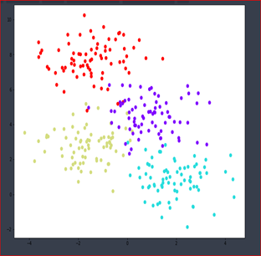

Figure 2: Feature distribution using blobs

Using a decision tree classifier, plots below were drawn to show the data distribution fitting of the features used. All the training points were plotted to show the fitting of the data.

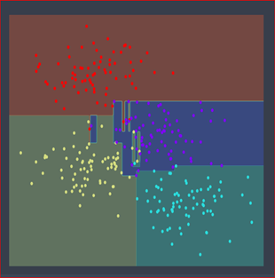

Figure 3: All training sets showing the data distribution fitting points

With the data split into its constituent labels and features and characterized successfully, the random forest classifier was then trained on the training set and predictions made on the test set which was a percentage of the whole data that is 0.33 of the data as the training set and the rest the prediction set using a Gaussian classifier.
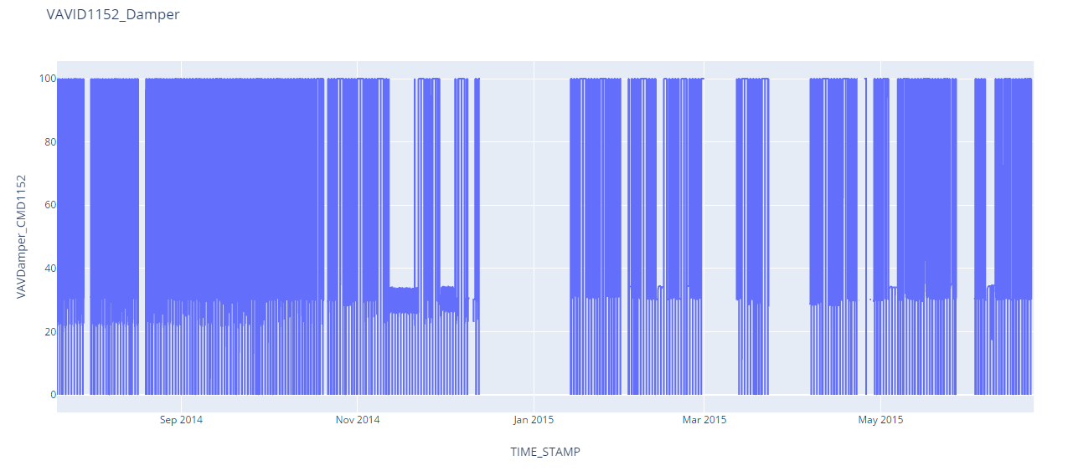
Once the classification was done, the accuracy of the actual values and the predicted values was checked and the recorded as 0.9868421052. A sample of the data was used for the testing of the model in order to predict the accuracy as shown in the following code.
Figure 5 Aggregate damper position (close percentage) over one year
For any estimator algorithm, the errors are decomposed into three main types. That is the average training error denoted by the bias error, the changes in accuracy and precision of the results caused by varying data sets which is referred to as variance and finally the noise which is the characteristic nature of the data to error. For any classifier algorithm, the bias and variance have to be set to be the lowest possible values. A validation curve was drawn to show the performance metric on the range of the data under test. The plots show the training test score and cross-validation score graphs for the data. One axis shows the number of trees on the x-axis used during the training while the other y-axis shows the accuracy of the training.

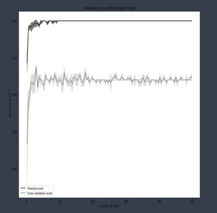
Figure 6 Sampling damper position data

Figure 4: Training validation Curve

Since the algorithm used in this case Random forest is a classification algorithm, validation curves are drawn instead of the learning curves which are commonly used in algorithms with regression fitting. While both learning and validation curve utilize the same methodology to arrive at the graphs, it is the error metric used that makes the difference. The accuracy score is used in the validation curve and describes how good the model is. The higher the accuracy, the better the model is. The Bayes error is often calculated when handling a classifier algorithm. The Bayes error rate gives us information on the best possible error that can be obtained in a learning machine given any set of data. Models that use a metric describing how good a model is often given an upper bound value on the irreducible error. In this case one cannot get higher than the irreducible error arrived at.

Intrusive vs. Non-Intrusive

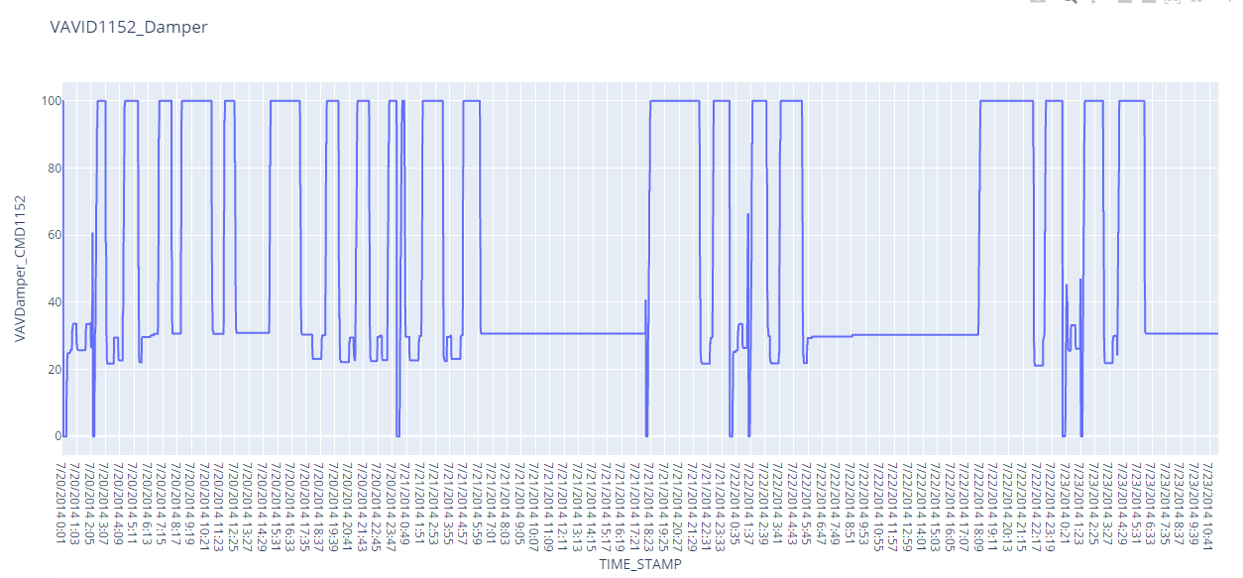
Intrusive and non-intrusive differ in how data is collected in order to address occupant privacy concerns. While boundaries can be established in order to limit privacy concerns, the ability to abuse or the potential for data breaches of the collected information still exist. These concerns usually emerge when data collection methods involve the recording of visual or audio.

4.1 Import data

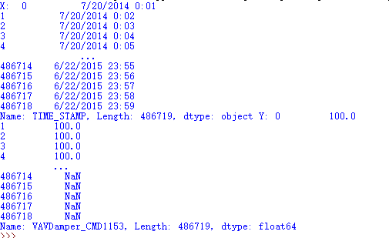
The dataset we used is centered on three office air handling units, the data we are dealing with is long-term. Each csv file is a time series that lasts for one year. Only selected columns are imported. (i.e. damper position or reheat valve) The X axis stands for time stamps. The Y axis of reheat valve has the unit of PSI show the reheat discharge. The Y axis of damper position is the percentage of its closure state. The magnitudes closer to 100% in figure 6 represented potential human occupancy. There are occupancy patterns can be visualized without any data processing. We later attempted to apply some machine learning algorithms to obtain apparent occupancy.

4.2 Data Cleaning

The sensors measurements data has noise and erroneous readings. Apply Frequency Decomposition and Filtering, canny edge detection as step change detection. The canny edge detection function is available in the python coding community. The main application of canny detection is smoothing images. Two types of step-edges are distinguished – an upward step-edge is a step-edge where the mean increases after the edge, and a downward step-edge where the mean decreases after the edge.

4.3 Modeling

Each sensor measurement will provide an occupancy indicative signal. Combine all measurements to derive an aggregate pattern involving multi-model estimation technique [2]. Several machine learning approaches exist that provide solutions to room occupancy detection where it is possible to predict the average number of occupants to very high accuracy. Each of these methods provides various algorithms standardized and published as techniques with specific applications. One approach is to use a supervised machine learning model. This uses labeled data which simulate an ideal situation of the scenario under investigation, the unsupervised model uses unmarked data while the semi-supervised approach gives a hybrid of both supervised and unsupervised learning (Brennan 47).
Machine learning models are most useful in custom applications where the data set provided is relatively small and the nature of features to be used in the algorithm is already known. A number of algorithms exist which can be used to analyze data from a building management system and predict various parameters. This includes using a K-nearest neighbor (KNN) classification, random forest, and support vector machines (Abade et. al). Other techniques include classification and regression trees, linear discriminant functions and extreme learning machines. Most of these algorithms have their advantages and disadvantages depending on where it is that they are applied.

4.3.1 K-Nearest Neighbors

The KNN algorithm is an example of a supervised approach to machine learning. It can be used to solve classification as well as regression problems. KNN algorithm is a non-parametric learning algorithm. It often takes a lot of time to run through all data points in order to process all underlying information in the data. This makes it relatively slow during the training phase and also a high memory consumption hence costlier to train a KNN model. Its training does not have a specialized training phase as it uses all the data for classification training, a property commonly known as lazy learning. It works by assigning a value based on feature similarity to anew data point that relates the data point to how close they are to other data points used in the training phase. It is preferred for its ability to process non-linear data both as a classifier and a regressor algorithm (Wang et. al). Its simplicity and ease of use make it a popular choice for many applications. Nearest neighbors are calculated based on the Euclidean distance (Wang et. al).
Figure 7 Sampling damper position data
For a KNN algorithm application, when given a data set defined by ($X_{k},Y_{k}$) and K is a series sequence with values K=1, 2 up to an unknown value N, and then the distance is calculated using the equation below:
$$d_{k}=\left\|t-X_{k}\right\|$$
Where t is the test sample and DK are the distance between t and $X_{k}$ while $X_{k}$is the sample value (Brennan 58).

4.3.2 Support Vector Machine

Support Vector Machine (SVM) is another classification algorithm that is used for supervised machine learning. It uses a discriminative principle to classify and separate objects using hyperplane transformations known as kernels (Wang et. al). Generally, this method requires a lot of time to find the perfect classifier for very large data sets hence the need for involving secondary parameters called regularization that allow the data to be tuned. This method has successfully been implemented for use in predicting occupancy levels. The model used in this case is highly dependent only on a subset of the training data (Wang et. al). This is because the cost function does not use training data close to the model prediction. A previously designed model follows the following two equations:
Minimizing the function:
$$\frac{1}{2}{\left\|ω\right\|}^{2}$$
Subject to the conditions given by the following inequalities:
$$y_{k}-〈ω, x_{i}〉-b≤ε$$

And
$${〈ω, x_{i}〉+b-y}_{k}≤ε$$

Where $x_{i}$ is a training sample, $y_{i}$ is the target, ε is the threshold, $〈ω, x_{i}〉$is the inner product, b is the y-intercept (Wang et. al).

4.3.3 Random Forest

Random forest is another type of classification algorithm which uses multiple decision trees to make decisions. The random forest finds many applications in areas such as object classification and multiclass object detection. This can be used for instance in identifying body parts, moving vehicles and sorting them into different sizes. Example applications such as the Kinect game uses the random forest to detect body movements and duplicate the movements using avatars in the game console. This algorithm is preferred since it avoids the risk of overfitting (Hong et. al). Additionally, the time required to train the model is usually very minimal which makes it cheaper to run over large databases. It is also able to fill in missing data by estimation and use the data to generate highly accurate results.
Figure 8 Canny detection testing in images

4.3.4 Decision tree

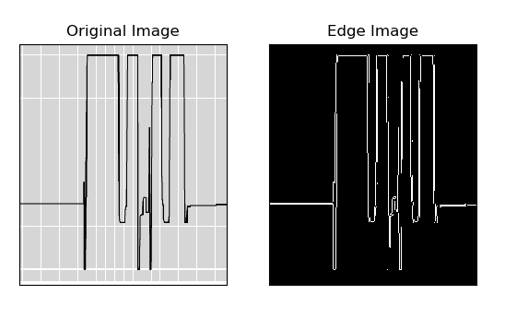
Decision tree refers to a process where a series of yes or no questions are used to make nodes with many sample points of features that clearly divide the data set into a class. Random forest is built on the concept of decision trees where multiple nodes are involved (Wang et. al). For a decision tree in a random forest algorithm, understanding the Gini impurity of the node which is the probability that any sample in a node will be incorrectly labeled if it was labeled using the node distribution (Brennan).
Figure 9 Canny detection testing in damper position data
It is calculated using the following mathematical equation:
$$I_{G}\left(n\right)=1-\sum_{i=1}^{J}{{\left(pi\right)}^{2}}$$
Where J refers to the sum over all classes for a binary classification task, pi refers to the fraction of the classification class examples and I_G (n) is the Gini impurity of a node n (Brennan).

When the Gini impurity is zero, this means it is not possible that a sample in that node could be classified in the wrong class (Hong et. al). Random forest is designed to avoid overfitting which occurs as a result of noise in the training data used when the data has high variations and the model is very flexible. Overfitting is avoided by randomly selecting subsets of features when splitting the nodes and randomly selecting training data points for each decision tree in the ensemble.
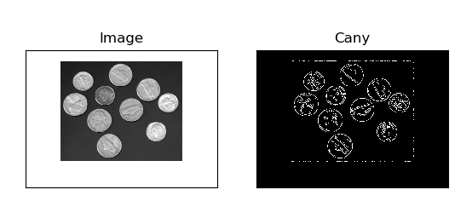
4.3.5 Step change detection
The original paper used Canny edge detection to infer the occupancy. This algorithm has been used in signal processing and computer vision. This can be decomposed into several steps:1)use Gaussian filter to smooth a signal; 2) compute the gradient of the smoothed signal; 3) find the local optima of the gradient of the smoothed signal and considered them as candidate edges; 4)apply a simple threshold technique to preserve strong edges among the candidate edges; 5) weak edges that are linked to the strong edges are added to the set of identified edges.
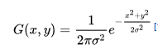
Gaussian filter is a non-linear filter that is a common way to reduce noise of a signal.

At the beginning stage of our research, we collected some algorithms of step edge detection to explore the effect and function of the Canny edge detection. The algorithm required an input of image type file (i.e. jpg or png). It detects the edges of coins and return a black-white image for the computer to analysis. We attempted to apply Canny edge detection on sample images to view if the results will assemble to the Figure 3 shown in the original paper with red lines indicating the occupancy patterns. In order to pass the indicative signal into Canny detection, we plot the sampling sensor data of damper position at one room and input the saved plot to Canny detection. As expectation, the Canny detection should detect the step change and indicate occupancy patterns. However, as shown in figure 9, the output figure remains the almost same as the original plot.

We learned deeper into the principles and objectives of this Canny detection. We tried to decompose Canny detection into just step change detection. By inputting some samples, we can produce
Figure 10 Step change detection
some models and further derive zone-customized HVAC schedules.

4. Energy savings Potential
The research has not proceeded to this section, in the planned methods, the modelled human occupancy models are compared with the ground truth intervals. The correlation between the model and ground truth shows the accuracy of the prediction.

Challenges
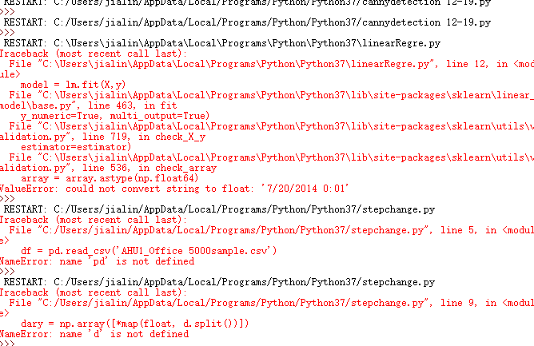
A mistake that was learned the hard way in this paper replication was that intrusive techniques can’t be used for a paper in which the data set was intrusive. Our original data set was one used by a researcher from the University of Virginia, the data set had rooms in an office building where CO2 and light sensors were used. When we wanted graphs, the best depiction attained was a scatter plot

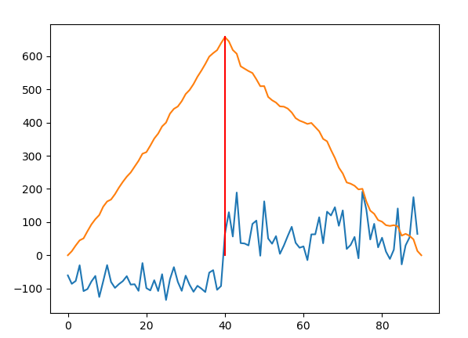

Figure 11 Python module running panel

The scatter plot was ineffective in determining when a person could have been within a room throughout the day. Since the algorithm i used was a classifier and had no regression, I could only obtain validation curves as shown in the original paper and scatter plots for the distribution of the data. The only safe conclusion that can be made from these scatter plot graphs is that one variable is affected by another, for example light usage and possible occupancy. Since we are using the pir sensor data as the dependent variable and all others humidity, temperature, co2 and light as independent variables and they are not exactly uniform in size, we realize it had to be sorted by the sensor id to match each of them

We initially used KETI dataset provided by our course advisor: The dataset used in our AISTATS'17 work contains the data for 5 different types of measurements from 50 rooms in an office building. [5] As the data been gathered and preprocessed, we found this dataset was not suitable for this reproducing paper. The Keti dataset used intrusive sensors such as co2 and temperature sensors, which is against the intension of developing a non-intrusive way of occupancy sensing. Secondly, the measurements contain huge amount of noise and unwanted points. The data preprocessing along required complex algorithm and steps. After we struggled in extracting useful information, with only two weeks remaining towards deadline, we abandoned this Keti dataset, instead, we looked for AHU or VAV system related data and found “ Long-term data on 3 office Air Handling Units on the website :https://openei.org/datasets/dataset/long-term-data-on-3-office-air-handling-units.

The original paper does not provide any algorithm or dataset. It leaves us an undirected issue to be solved in order to mimic the similar results. With zero fundamentals in python programming, we the team began this project from building the python environment in our laptops. We studied online tutorials and sample code to create our own for specific objectives. In every code that we implemented, errors occurred. Due to little familiarity with python language, variables and syntax are the major barriers we encountered during coding experience.

Ground truths of large commercial building are almost impossible to obtain due to the large size of room numbers and huge resource expenses. In the original paper, the researchers believed that stratified sampling of occupancy is essential in developing the solution. They manually log the occupancy hours of 7 private and shared offices over the period of two weeks where these rooms are selected as at least one interior and one perimeter zone in each building. Besides, they accessed the security camera to extract occupancy ground truth. For this paper, we are not capable to access to any commercial building’s camera database or conduct manual log. In this case, no ground truth is available to be compared with the prediction. The solution will be applying the same algorithms in the complete process to produce another human occupancy pattern and then compare the similarities and discretion between them. This can be the possible future work.

Conclusion

Our first attempt at replicating a paper with non-intrusive data by an intrusive data set went like this. Occupancy prediction using machine techniques has captured growing attention in many studies by addressing the applications of environmental parameters (e.g., CO2, temperature, and relative humidity) or the Wi-Fi technology. The machine learning model was initially successfully implemented and the training model tested. The results obtained were displayed procedurally using the Jupyter notebook's code. Due to the large dataset, it was difficult to run through the entire data in one cycle since smaller machines had memory limitations. As a result, a single folder was used to train the random forest classifier model. Recommendations for solving this problem require a categorized approach to training where a step by step incremental approach is used. Alternatively, using a large memory computing device would reduce the memory error limitations allowing for more data to be used at once. Reducing bias, variance and noise in the model is necessary to produce models with good results. An accuracy obtained for instance was 0.973684 which is well within the expected margins for application. The advantages of using the random forest method were visible with the model. Its ease of training was notably seen in the application as the code compiled faster. The run time during training was impressively very fast during training and no overfitting problems were experienced. Besides missing values did not affect the algorithm results output where some sensor nodes did not register a given parameter value. Using the sckitlearn library also made it very easy to model machine learning algorithms with fewer code. Future work would include performing feature extraction where the environmental parameter that makes more impact on predicting room occupancy is identified relative to the others for the model. This would provide more focused approach to machine learning based on the identified parameter.

FUTURE WORK

In this paper we attempted to gain a higher accuracy with a larger data set. For first timers we feel that we learned a few things that Machine Learning professionals could take heed. Our results indicate that the constructed algorithm/code performed decently. For future endeavors regarding human occupancy within a building facility setting, researchers should apply more sophisticated methods for associating occupancy with non-intrusive variables such as power or water usage. To expand on this idea, let’s picture a researcher resorting to the standard method of utilizing a binary classifier which only categorizes the elements of a given set into two groups... the researcher can rather focus on determining the probability of occupancy based on variables such as electricity, HVAC or water usage. However, these techniques have the drawback of requiring some
form of training data, which is challenging and time-consuming to collect and our current approach avoids. It is necessary to study the full correlation of the environmental data used in this research. A starting point could be the analysis of features and their impact on the system. The CO2 data have to endure some processing to find the most meaningful way to use this type of data, since it was found that they represent one of the best features to detect the number of occupants.
Another suggestion that I have is the implementation of the shift-scaled dirichlet distribution(SSDD). The Dirichlet distribution Dir(α) is a family of continuous multivariate probability distributions parameterized by a vector α of positive reals. It is a multivariate generalization of the Beta distribution. Dirichlet distributions are commonly used as prior distributions in Bayesian statistics.

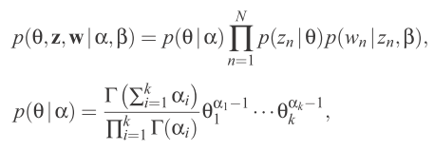

This model implementation would be extremely useful in studies focusing on occupancy detection because it can help in determining probabilities of occupancy.

Clustering techniques are supposed to be applied after occupancy patterns being derived. Cluster analysis or clustering is the task of grouping a set of objects in such a way that objects in the same group are more similar to each other than to those in other groups. Groups of zones will be gathered and treated as a cluster who has similar occupancy patterns. The system will extract and compare those information to provide customized schedules to archive energy savings.
After the data was processed, the models of human occupancy patterns will end up being generated. The ideal patterns will include the time periods of human presence in a day, week, and weekend. The original paper had generated different schedules: Static and adaptive schedules. This will be our paper’s final goal and can be applied towards energy savings.

REFERENCES

[1] BuildSys '16 Proceedings of the 3rd ACM International Conference on Systems for Energy-Efficient Built Environments Pages 21-30
[2] Irvan Arief-Ang, Margaret Hamilton, Flora Dilys Salim “A Scalable Room Occupancy Prediction with Transferable Time Series Decomposition of CO2 Sensor Data”. October 2018ACM Transactions on Sensor Networks 14(3-4)
[3] M.S.ZuraimiA.PantazarasK.A.ChaturvediJ.J.YangK.W.ThamS.E.Lee “Predicting occupancy counts using physical and statistical Co2-based modeling methodologies” Building and Environment Volume 123, October 2017, Pages 517-528
[4] ©2011. American Society of Heating, Refrigerating and Air-Conditioning Engineers, Inc. (www.ashrae.org). Published in ASHRAE Transactions, Volume 117, Part 2. Occupancy Based Control Strategy for Variable-Air-Volume (VAV) Terminal Box Systems
[5] Dezhi Hong, Quanquan Gu, Kamin Whitehouse. High-dimensional Time Series Clustering via Cross-Predictability.In AISTATS'17
[6] Abade, Bruno, David Perez Abreu, and Marilia Curado. "A Non-Intrusive Approach for Indoor Occupancy Detection in Smart Environments." Sensors 18.11 (2018): 3953.
[7] Brennan, Colin. Machine Learning for Non-invasive Room Occupancy Estimation. Diss. 2018.
[8]Hong, Dezhi, Quanquan Gu, and Kamin Whitehouse. "High-dimensional time series clustering via cross-predictability." Artificial Intelligence and Statistics. 2017.
[9]Wang, Wei, Jiayu Chen, and Tianzhen Hong. "Occupancy prediction through machine learning and data fusion of environmental sensing and Wi-Fi sensing in buildings." Automation in Construction 94 (2018): 233-243.

